The Market For Organs Policy Brief
Name
Institution

To Governor Scott
The market for organs Policy brief
Background
The healthcare environment has been dogged by a series of challenges which limit the effective delivery of care. Even though technological changes have been integrated within healthcare, they have been unable to solve the recurring problem of organ shortage. More than 120,000 patients are waiting in line for organ transplant with approximately 21 Americans dying on a daily basis because they are unable to get essential organs that could have saved their lives (Cherry, 2015). Technology is playing an essential role in transforming healthcare although it is essential to understand that technological solutions towards organ transplant is still far away while their need to make an urgent decision that will have a positive influence on individuals within the state. Development of an organ market is the only viable solution currently that will provide an end to organ shortage and save the lives of many individuals.
However even though the implementation of an organ market is a crucial solution to consider, it has been significantly condemned for its unethical nature. It is the responsibility of the government to take all the risky options to make an accurate determination regarding the best alternative to consider regarding organ transplant. Development of Organ market creates a better environment where individuals who a medical need can effectively interact in the market to have their problems solved. Organ transplant identifies better concepts which define a highly successful focus on better elements that define successful public health. Many individuals are dying because there is no better network which could easily link them to possible donors or locations where they can quickly get these organs at an affordable price (Cohen, 2017).
Development of organ market within the state is not very difficult considering that there are demand and need for organs across different locations. The best approach, in this case, should consider providing a highly streamlined delivery system which will be essential in creating a profoundly transformed setting where it would be possible to improve healthcare outcomes. There are very few changes that need to be incorporated within healthcare where it would be possible to improve the quality of the distribution strategy that will be adopted. A few changes to the current healthcare procurement system will provide a better emphasis on better concepts that are defined within the delivery of quality healthcare through ease to access organs in the market. The move will have a positive influence on health outcomes which identifies one of the most significant societal needs that the government should highly consider (Koplin,2014).
Currently, even though the sale of organs is prohibited, individuals are allowed to make organ donations. The Organ Procurement and Transplantation Network provide an extreme emphasis on the procurement process that provides for better facilitation of organs. Therefore, to have a thriving market, the input of the OPTN is necessary for defining better ways that individuals can sell their organs and ensure that they are stored successfully. Organ donation has been significantly promoted to save the lives of other individuals. The donor is not able to benefit from the donation of his or her organ. Therefore, it would be essential to help define a highly effective understanding of better outcomes (Ahmad & Iftikhar, 2016).
There is a need to focus on the lives of the community members and evaluate their willingness to have the organs market with a clear focus on improving their health concerns. It is essential to assess the effects of organ market within the state with a critical focus on the healthcare needs of community members and the cost involved. Organ shortage is a global healthcare concern thus it is essential to make these bold decisions which define a strong focus on better healthcare outcomes. Currently, it is complicated to acquire an organ because they are presumed unavailable mainly because many individuals do not know the whole process of selling as well as finding a voluntary seller. The development of the market will ensure a very streamlined environment where it would be possible to conduct business through positive engagement (Mayrhofer-Reinhartshuber & Fitzgerald, 2015).
The state has a very small healthcare budget lack highly advanced healthcare equipment. This means that the state needs to focus on implementing major decisions that have a positive influence on the delivery of quality healthcare through the development of an organ market which will provide major medical challenges as technological innovations within the healthcare targeting organs continue to be evaluated to solve the problem in the future. Therefore, allowing the sale of organs will help understand the needs of individuals so that they can be effectively compensated to improve the healthcare outcomes of other individuals. The state is required to make better decisions regarding their approach to the organ market and what to expect (Cherry, 2015).
The state should be able to outline essential procedures that govern organ market to ensure that the sellers of organs do not risk their lives by selling their organs. Developing an organ market provide a highly effective focus on key concepts that define positive development within the society. Developing organ market is the only viable solution to organ shortage within the state as well as other parts. Therefore, in deciding the development of organ markets within the state, you should review the potential health benefits as well as costs based on the limited state budget (Cohen, 2017).
Demand and supply for organs
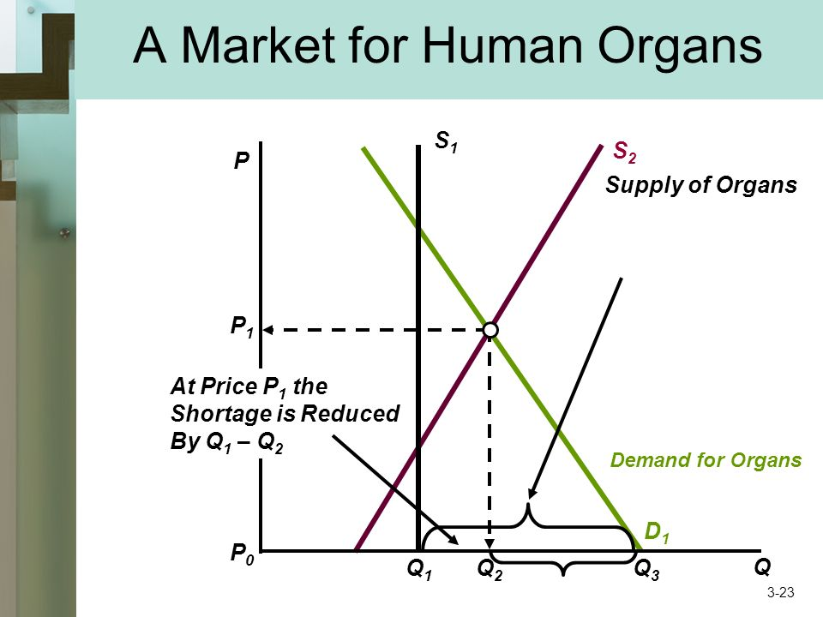
Figure 1: Organ demand and supply

Organ transplant in rates
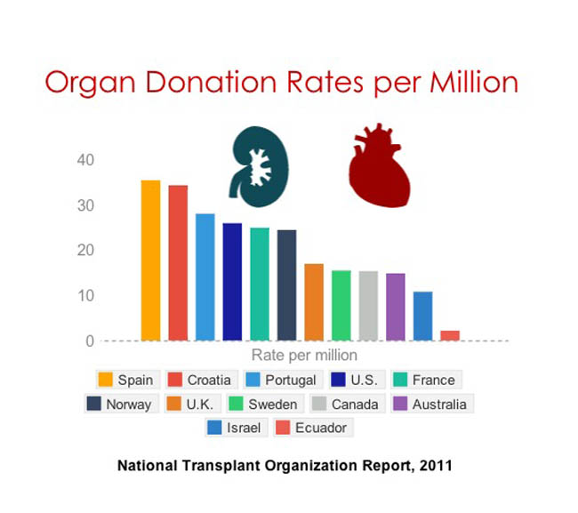
Figure 2: Organ donation rates
Organ waiting times
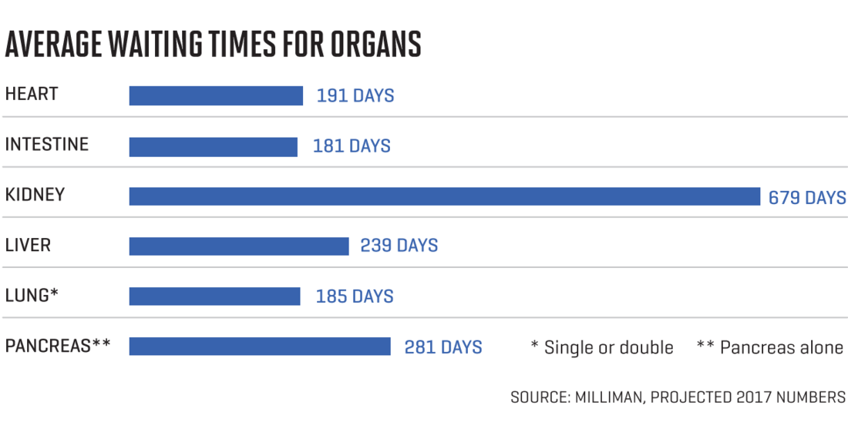
Figure 3: Average waiting times for organs
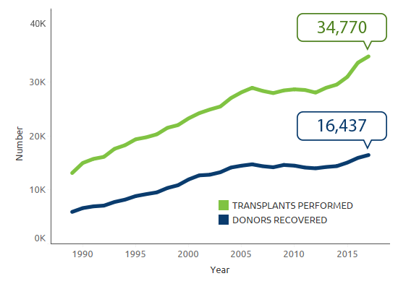
Figure 4: Organ procurement and donor recovery
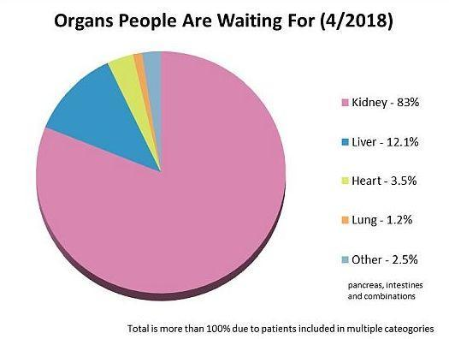
Figure 5: Organs people are waiting for
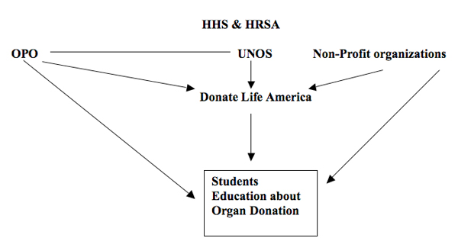
Figure 6: Organ donation framework

References
Ahmad, G., & Iftikhar, S. (2016). An analysis of organ donation policy in the united states. Rhode Island Medical Journal, 99(5), 25.
Cherry, M. J. (2015). Kidney for sale by owner: human organs, transplantation, and the market. Georgetown University Press.
Cohen, L. R. (2017). Increasing the supply of transplant organs: the virtues of a futures market. In Organ and Tissue Transplantation (pp. 121-171). Routledge.
Koplin, J. (2014). Assessing the likely harms to kidney vendors in regulated organ markets. The American Journal of Bioethics, 14(10), 7-18.
Mayrhofer-Reinhartshuber, D., & Fitzgerald, R. (2015). Financial incentives for cadaveric organ donation. Replacement Parts: The Ethics of Procuring and Replacing Organs in Humans, 162.

